RECEIPT DECEIT
An Invisible Problem
With shopping culture growing across the globe, the evidence of purchase becomes tangible in the form of receipts. Although some may be kept in boxes for preservation and protection, much of this paper proof gets discarded in recycling bins. Which would not be as much of a problem if they WERE in fact recyclable, however the plastic coating present in many of the paper receipts carry chemicals named BPS and BPA. Which produces shiny, soft thermal paper from newer cash registers and debit machines. If dark lines appear on the receipts when scratched, then they contain the mentioned chemicals and are called thermal receipts.
Chemicals Getting in The Way
Thermal receipts have a coating of the chemical bisphenol-A or BPA. The coated paper runs through a printing machine that uses dot formations to produce the letters and graphics. The paper is heated up as it runs through a roller, and the heat causes a chemical reaction to occur where it is focused. This results in a visible black text on the paper. With a technique that is easier and cheaper than using ink printers, thermal receipts are much more common than paper ones.
If thermal paper were to be recycled, it would contaminate other products in the recycling stream with BPA or BPS. These products are often turned into items such as facial tissue, paper towels, or shopping bags.
So, What Is the Harm?
Having BPA or BPS in them would mean coming in close contact with the chemical.
BPA and BPS are known hormone disruptors that can affect brain development, heart, lung and prostate health, mammary glands, and reproductive abilities. They can be transferred from fingers to the mouth via food or absorbed directly through the skin when held. The Environmental Working Group reported that bisphenol-A transfers from receipts to skin and can penetrate the skin to such a depth that it cannot be washed off. If you have wet or greasy hands or use hand sanitizer or lotion after handling a receipt, the absorption happens even more rapidly. According to Safer Chemicals, Healthy Families, these chemicals can easily transfer to anything a receipt touches — your hand, the money in your wallet, or even the groceries in your shopping bag.
What Can Be Done?
Burning and composting are not an option as they would release BPA and BPS into the atmosphere or soil. Unless you are certain that your receipts are pure paper, do not throw them in recycling bins.
Instead, either ask for a digital receipt when at the checkout or throw already existing receipts in paper recycling bins. As well as educating your peers and social circles about the subject.

Awareness
Although the people who read this article are made aware of the mentioned problem and its possible replacements, many adults and children continue their lives unaware of these facts, exposing themselves and loved ones to dangerous chemicals in the long run.
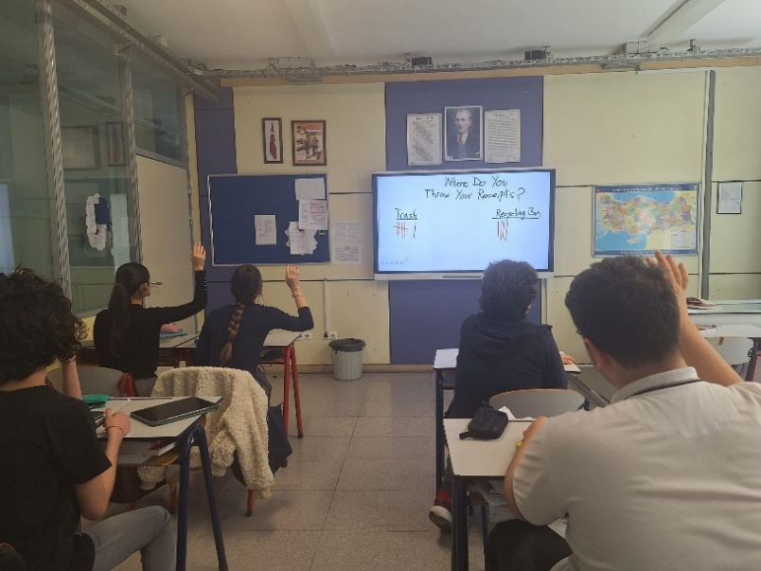
In a survey conducted in several classes and within parents of students, it was found that the majority threw their receipts in regular trash bins, and the people who used recycling bins were not aware of the fact that these kinds of paper could not be recycled.
To face this problem, Young Reporters for the Environment club in our school decided to provide multiple ways to inform people throughout the school and on the internet.
Figure 1: Survey In Class
I EAT RECEIPTS
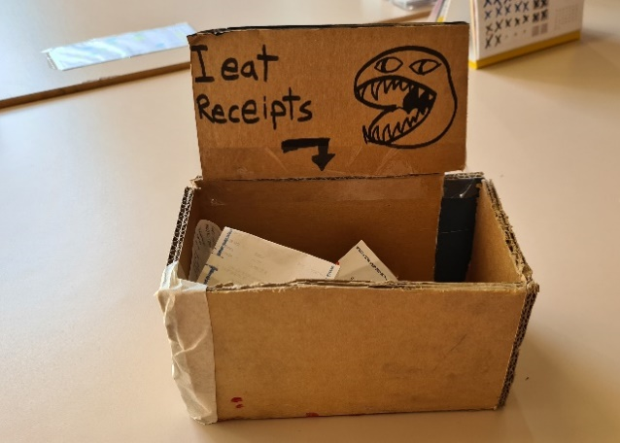
These cardboard boxes placed mainly in teachers’ lounges create a comical way of participation, encouraging people to feed the drawing of a hungry creature while helping them empty their bags and wallets full of unnecessary receipts. Within a month of placing these boxes, we collected thousands of receipts, then proceeded to use a fraction of them to construct a striking art piece. The rest of the receipts were boxed up to be used in future projects.
Figure 2:I EAT RECEIPTS box
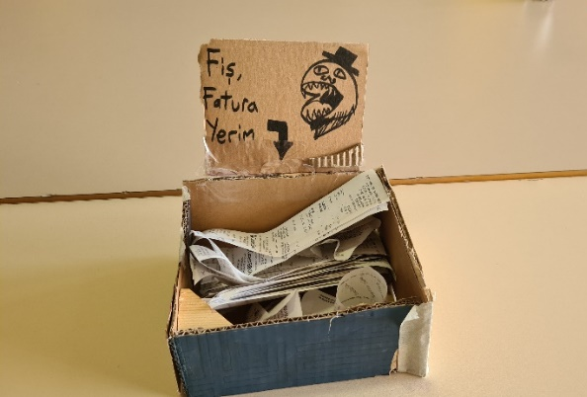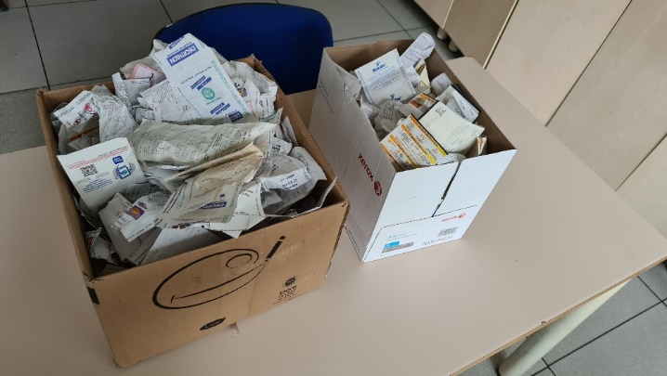
Figure 3: I EAT RECEIPTS box in Turkish Figure 4: Boxes Full of Discarded Receipts

Abandoned First
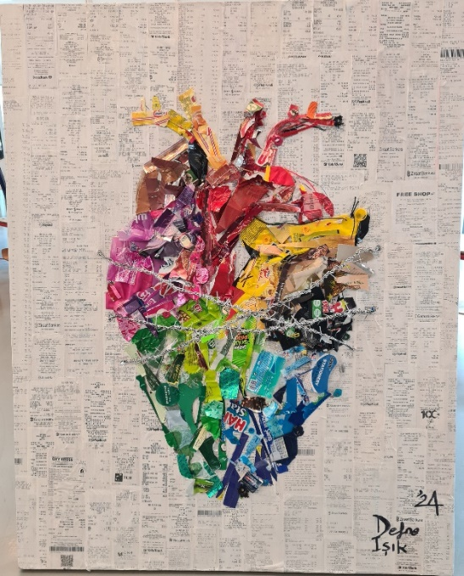
With the intention of raising awareness of the “receipt deceit” excess receipts collected in a month were used to create a striking background on a 100 x 80cm canvas Moreover, the scrap pieces of disposable products were gathered in 6 months which were later separated by color and placed thoughtfully to resemble the most sympathetic symbol of all: the human heart. The embodiment of compassion.
This piece was named “Abandoned First” after its contents, the first pieces we get rid of when a bin is in sight. By using art to spread a message, we unlocked a new chapter on our report’s journey.

Figure 5: “Abondoned First” by Ülker Defne IŞIK

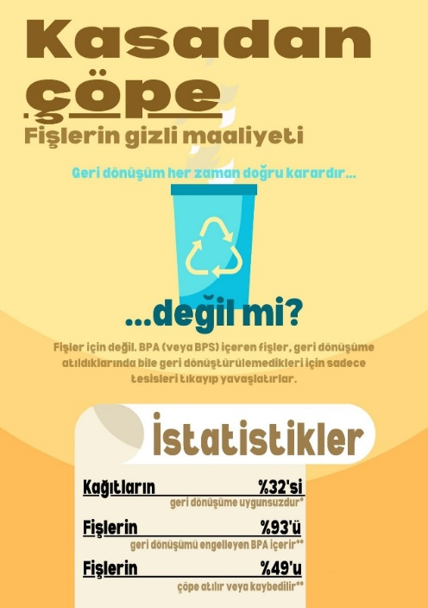
INFORMATION HERE, THERE, INFORMATION EVERYWHERE
Apart from the previously mentioned projects, our club designed and printed informative posters all about receipts after thorough research into the subject. These posters will soon be hung throughout the school for every passing student/ teacher/ employee in the school to see.

Figure 6: Poster About Receipts

WRITERS
Ülker Defne IŞIK
Ekin DİVRİK
CLUB ADMINISTRATOR
Dr. Sinem ÖDÜN BAŞKIRAN

REFERENCES
https://www.solopress.com/blog/print-inspiration/direct-thermal-print/
https://everydayrecycler.com/are-receipts-recyclable/#:~:text=The%20Wrap,go%20into%20the%20trash%20can.
https://www.parcelhero.com/research/study-stamping-out-receipts
https://www.treehugger.com/can-receipts-be-recycled-5072255#:~:text=Most%20paper%20receipts%20are%20not,paper%20during%20the%20recycling%20process.
https://www.shoeboxed.com/blog/are-receipts-recyclable/
https://brightly.eco/blog/are-receipts-recyclable
https://cubecloud.eu/2022/01/18/save-forests-water-energy-reduce-your-carbon-
footprint/#:~:text=Receipts%20kill%20trees%20and%20harm,as%2063%25%20for%20paper%20production.&amp;text=Demand%20for%20US%
20receipt%20paper,just%20to%20produce%20paper%20receipts.

